Human Anatomy, 9e (Martini)
Chapter 1 Foundations: An Introduction to Anatomy

1.1 Multiple Choice Questions

1) It is important to study the discipline of anatomy because it ________.
A) is important to understand the link between human structure and function
B) develop a three-dimensional understanding of anatomical relationships
C) will assist individuals to make informed decisions about their personal health
D) provides a basis for understanding more advanced courses in anatomy, physiology, and related disciplines
E) All of the answers are correct.
Answer: E
Learning Outcome: 1.1
Bloom's Taxonomy: 1-2: Remembering/Understanding

2) Which of the following statements about anatomical information is correct?
A) Anatomic information is all historical.
B) It describes external and internal structures of the body and considers probable function.
C) It addresses large body structures visible to the naked eye only.
D) Physiology and anatomy are unrelated.
E) The study of cells or cytology is useless to anatomy.
Answer: B
Learning Outcome: 1.1
Bloom's Taxonomy: 1-2: Remembering/Understanding

3) The branch of science that studies groups of specialized cells and how they work together is called ________.
A) physiology
B) histology
C) anatomy
D) cytology
E) None of the answers are correct.
Answer: B
Learning Outcome: 1.1
Bloom's Taxonomy: 1-2: Remembering/Understanding

4) The analysis of the smallest units of life is called ________.
A) embryology
B) cytology
C) physiology
D) histology
E) morphology
Answer: B
Learning Outcome: 1.1
Bloom's Taxonomy: 1-2: Remembering/Understanding
5) The discipline that might examine structural interactions within a sheet of muscle tissue, or groups of specialized cells and cell products that work together to perform specific functions, is called ________.
A) morphology
B) radiology
C) embryology
D) histology
E) cytology
Answer: D
Learning Outcome: 1.1
Bloom's Taxonomy: 1-2: Remembering/Understanding

6) The anatomical specialty that refers to the study of general form (or morphology) and superficial anatomical markings is called ________.
A) surface anatomy
B) comparative anatomy
C) regional anatomy
D) developmental anatomy
E) systemic anatomy
Answer: A
Learning Outcome: 1.2
Bloom's Taxonomy: 1-2: Remembering/Understanding

7) Which type of anatomy refers to the study of all of the superficial and internal features in a specific area of the body?
A) surface anatomy
B) regional anatomy
C) systemic anatomy
D) gross anatomy
E) microscopic anatomy
Answer: B
Learning Outcome: 1.2
Bloom's Taxonomy: 1-2: Remembering/Understanding

8) The study of the heart, blood, and blood vessels is which of the following approaches?
A) systemic anatomy
B) regional anatomy
C) developmental anatomy
D) surface anatomy
E) gross anatomy
Answer: A
Learning Outcome: 1.2
Bloom's Taxonomy: 1-2: Remembering/Understanding
9) The study of the early processes during the first two months of development from conception is called ________.
A) cytology
B) physiology
C) histology
D) embryology
E) osteology
Answer: D
Learning Outcome: 1.3
Bloom's Taxonomy: 1-2: Remembering/Understanding

10) The study of structures through specialized imaging techniques, such as ultrasounds, x-rays, or other specialized procedures performed on an intact body, is called ________.
A) cytology
B) embryology
C) physiology
D) histology
E) radiography
Answer: E
Learning Outcome: 1.3
Bloom's Taxonomy: 1-2: Remembering/Understanding

11) Gross anatomical specialties include ________.
A) radiographic and surgical anatomy
B) cytology and embryology
C) histology
D) radiographic anatomy, surgical anatomy, cytology and embryology
E) cytology, histology and embryology
Answer: A
Learning Outcome: 1.3
Bloom's Taxonomy: 1-2: Remembering/Understanding

12) The study of anatomical features that may undergo recognizable pathological changes during illness is called ________ anatomy.
A) clinical
B) developmental
C) comparative
D) systemic
E) regional
Answer: A
Learning Outcome: 1.3
Bloom's Taxonomy: 1-2: Remembering/Understanding
13) ________ anatomy is a new subspecialty of gross anatomy as new advances, such as computed tomography and spiral CT scans, have emerged.
A) Surgical
B) Developmental
C) Cross-sectional
D) Regional
E) Comparative
Answer: C
Learning Outcome: 1.3
Bloom's Taxonomy: 1-2: Remembering/Understanding

14) Disease is the failure to maintain ________ conditions.
A) metabolic
B) homeostatic
C) allostatic
D) physiological
E) pathological
Answer: B
Learning Outcome: 1.3
Bloom's Taxonomy: 1-2: Remembering/Understanding

15) Which of the following is the highest level of organization?
A) chemical
B) organelles
C) cellular
D) tissues
E) organs
Answer: E
Learning Outcome: 1.4
Bloom's Taxonomy: 1-2: Remembering/Understanding

16) The study of disease is ________.
A) radiology
B) pathology
C) histology
D) neurology
E) cardiology
Answer: B
Learning Outcome: 1.4
Bloom's Taxonomy: 1-2: Remembering/Understanding
17) Choose the correct arrangement of items 1-5, ranking them from the highest to the lowest level of complexity.
(1) organism
(2) tissue
(3) chemical or molecular
(4) cellular
(5) organ system
A) 1, 2, 3, 4, 5
B) 5, 4, 3, 2, 1
C) 1, 5, 2, 4, 3
D) 5, 3, 2, 4, 1
E) 2, 4, 1, 5, 3
Answer: C
Learning Outcome: 1.4
Bloom's Taxonomy: 1-2: Remembering/Understanding

18) The basic functions performed by all living humans include(s) ________.
A) excretion
B) metabolism
C) growth and differentiation
D) movement
E) All of the answers are correct.
Answer: E
Learning Outcome: 1.5
Bloom's Taxonomy: 1-2: Remembering/Understanding

19) The vital ability of an organism to take certain actions when changes occur in its immediate environment is called ________.
A) movement
B) growth
C) responsiveness
D) metabolism
E) excretion
Answer: C
Learning Outcome: 1.5
Bloom's Taxonomy: 1-2: Remembering/Understanding

20) Which of the following refers to all the chemical operations under way in the body?
A) anabolism
B) respiration
C) absorption
D) metabolism
E) excretion
Answer: D
Learning Outcome: 1.5
Bloom's Taxonomy: 1-2: Remembering/Understanding
21) Excretion involves ________.
A) changes to adjust to an organism's environment
B) creation of a new generation of individuals
C) transport of substances within an organism
D) elimination of unnecessary or potentially harmful materials metabolic waste from the body
E) locomotion of the body
Answer: D
Learning Outcome: 1.5
Bloom's Taxonomy: 1-2: Remembering/Understanding

22) Growth and differentiation often include ________.
A) specialization of individual cells
B) increase in cell size
C) increase in cell numbers
D) changes in form and function
E) All of the answers are correct.
Answer: E
Learning Outcome: 1.5
Bloom's Taxonomy: 1-2: Remembering/Understanding

23) Support, protection of soft tissues, mineral storage, and blood cell formation are all functions of the ________.
A) skeletal system
B) cardiovascular system
C) immune system
D) reproductive system
E) excretory system
Answer: A
Learning Outcome: 1.5
Bloom's Taxonomy: 1-2: Remembering/Understanding

24) Directing immediate responses to stimuli, usually by coordinating the activities of other organ systems is the function of the ________.
A) integumentary system
B) endocrine system
C) urinary system
D) nervous system
E) reproductive system
Answer: D
Learning Outcome: 1.5
Bloom's Taxonomy: 1-2: Remembering/Understanding
25) The major functions of the ________ system are temperature control and protection of the body from the external environmental hazards.
A) digestive
B) cardiovascular
C) urinary
D) respiratory
E) integumentary
Answer: E
Learning Outcome: 1.5
Bloom's Taxonomy: 1-2: Remembering/Understanding

26) The primary site of blood cell production is within the ________.
A) cardiovascular system
B) skeletal system
C) integumentary system
D) lymphatic system
E) endocrine system
Answer: B
Learning Outcome: 1.5
Bloom's Taxonomy: 1-2: Remembering/Understanding

27) Components of the urinary system include ________.
A) ureters and kidneys
B) liver and pancreas
C) thymus and spleen
D) bronchi and alveoli
E) None of the answers are correct.
Answer: A
Learning Outcome: 1.5
Bloom's Taxonomy: 1-2: Remembering/Understanding

28) Organs systems are a component of the integumentary system which includes ________.
A) anatomical units with related functions
B) formed by two or more organs
C) often large enough to be studied without magnification
D) interdependent on each other
E) All of the answers are correct.
Answer: E
Learning Outcome: 1.5
Bloom's Taxonomy: 1-2: Remembering/Understanding

29) Which of the following is the primary function of the thymus in the lymphatic system?
A) controls the development and maintenance of one class of lymphocytes
B) engulfs pathogens
C) monitors circulating blood
D) carries lymph and lymphocytes from peripheral tissues to the veins of the cardiovascular system
E) monitors the composition of lymph
Answer: A
Learning Outcome: 1.5
Bloom's Taxonomy: 1-2: Remembering/Understanding
30) Which of the following is NOT a primary function of the kidneys in the urinary system?
A) form and concentrate urine
B) regulate blood pH and ion concentrations
C) perform endocrine functions
D) All are primary functions of the kidneys.
E) None of the answers are primary functions of the kidneys.
Answer: D
Learning Outcome: 1.5
Bloom's Taxonomy: 1-2: Remembering/Understanding

31) The process of creating subsequent generations, either unicellular or multicellular, is referred to as ________.
A) growth
B) reproduction
C) metabolism
D) differentiation
E) responsiveness
Answer: B
Learning Outcome: 1.5
Bloom's Taxonomy: 1-2: Remembering/Understanding

32) The process of cellular specialization to perform particular functions is called ________.
A) reproduction
B) differentiation
C) growth
D) irritability
E) anabolism
Answer: B
Learning Outcome: 1.5
Bloom's Taxonomy: 1-2: Remembering/Understanding

33) The property of living things to transport food, blood, or other materials inside the body is called ________.
A) digestion
B) respiration
C) catabolism
D) growth
E) movement
Answer: E
Learning Outcome: 1.5
Bloom's Taxonomy: 1-2: Remembering/Understanding

34) The ________ system contains glandular structures that direct long-term changes in the activities of other organ systems.
A) nervous
B) cardiovascular
C) integumentary
D) endocrine
E) lymphatic
Answer: D
Learning Outcome: 1.5
Bloom's Taxonomy: 1-2: Remembering/Understanding
35) The ________ system allows for locomotion, provides support, and produces heat.
A) integumentary
B) skeletal
C) muscular
D) cardiovascular
E) digestive
Answer: C
Learning Outcome: 1.5
Bloom's Taxonomy: 1-2: Remembering/Understanding

36) The ________ system allows for gas exchange between the air and circulating blood.
A) respiratory
B) urinary
C) digestive
D) lymphatic
E) cardiovascular
Answer: A
Learning Outcome: 1.5
Bloom's Taxonomy: 1-2: Remembering/Understanding

37) Gas exchange is also facilitated by the ________ system, which is responsible for the internal transport of cells and dissolved materials, including nutrients, wastes, and gases.
A) urinary
B) digestive
C) cardiovascular
D) respiratory
E) lymphatic
Answer: C
Learning Outcome: 1.5
Bloom's Taxonomy: 1-2: Remembering/Understanding

38) In the prone position, ________.
A) the body faces posteriorly
B) the body is lying in anatomical position face up
C) the body is lying in anatomical position face down
D) the head is turned to the left, and the eyes are closed
E) the body is situated facing posteriorly and the eyes are open.
Answer: C
Learning Outcome: 1.6
Bloom's Taxonomy: 1-2: Remembering/Understanding

39) In anatomical position, a person stands with the legs together and the feet flat on the floor. Additionally, the ________.
A) hands are raised above the head
B) hands are facing posteriorly
C) hands are hanging naturally at the person's sides
D) hands are at the sides, and the palms face anteriorly
E) hands are facing laterally
Answer: D
Learning Outcome: 1.6
Bloom's Taxonomy: 1-2: Remembering/Understanding
40) A frontal (coronal) section is in a plane that ________.
A) divides the body along the midline
B) divides the body into left and right sections
C) divides the body into anterior and posterior sections
D) divides the body into superior and inferior sections
E) divides the body into frontal sections
Answer: C
Learning Outcome: 1.6
Bloom's Taxonomy: 1-2: Remembering/Understanding

41) Which of the following directional reference pairs consists of anatomical equivalents when referring to the human body?
A) distal, medial
B) proximal, lateral
C) cranial, caudal
D) cephalic, posterior
E) anterior, ventral
Answer: E
Learning Outcome: 1.6
Bloom's Taxonomy: 1-2: Remembering/Understanding

42) Which of the following is the most inferior of the nine abdominopelvic regions?
A) hypochondriac region
B) hypogastric region
C) umbilical region
D) left lumbar region
E) epigastric region
Answer: B
Learning Outcome: 1.6
Bloom's Taxonomy: 1-2: Remembering/Understanding

43) Which of the following includes only structures enclosed within the mediastinum?
A) lungs, esophagus, heart
B) heart, trachea, lungs
C) esophagus, trachea, thymus
D) pharynx, thymus, major vessels
E) brain, spinal cord
Answer: C
Learning Outcome: 1.6
Bloom's Taxonomy: 1-2: Remembering/Understanding

44) The serous membrane that covers the outer surface of a lung is called the ________.
A) visceral peritoneum
B) parietal pericardium
C) visceral pleura
D) parietal mesentery
E) None of the answers are correct.
Answer: C
Learning Outcome: 1.6
Bloom's Taxonomy: 1-2: Remembering/Understanding
45) The ________ lines the body wall within the abdominopelvic peritoneal cavity.
A) visceral pleura
B) parietal pericardium
C) mesentery proper
D) superficial fascia
E) parietal peritoneum
Answer: E
Learning Outcome: 1.6
Bloom's Taxonomy: 1-2: Remembering/Understanding

46) Mesenteries ________.
A) provide support and stability to the stomach and small intestine
B) allow movement of abdominal structures
C) support and stabilize organs such as the kidneys
D) All of the answers are correct.
E) None of the answers are correct.
Answer: A
Learning Outcome: 1.6
Bloom's Taxonomy: 1-2: Remembering/Understanding

47) The thoracic cavity is separated from the abdominopelvic cavity by ________.
A) the inferior border of the rib cage
B) a sheet of connective tissue
C) the diaphragm
D) the liver
E) None of the answers are correct.
Answer: C
Learning Outcome: 1.6
Bloom's Taxonomy: 1-2: Remembering/Understanding

48) The space that contains organs of the respiratory, cardiovascular, digestive, urine, and reproductive systems is called the ________.
A) mediastinum
B) pleural cavity
C) mesentery proper
D) pelvic cavity
E) None of these choices are correct.
Answer: E
Learning Outcome: 1.6
Bloom's Taxonomy: 1-2: Remembering/Understanding

49) The pericardial cavity contains which of the following?
A) heart
B) liver
C) intestines
D) brain
E) both the heart and the liver
Answer: A
Learning Outcome: 1.6
Bloom's Taxonomy: 1-2: Remembering/Understanding
50) A person lying down in the anatomical position is said to be ________ when lying face up.
A) homeostatic
B) prone
C) superficial
D) supine
E) ventral
Answer: D
Learning Outcome: 1.6
Bloom's Taxonomy: 1-2: Remembering/Understanding

51) Which of the following organs occupies the pleural cavity?
A) trachea
B) heart
C) lungs
D) esophagus
E) thyroid gland
Answer: C
Learning Outcome: 1.6
Bloom's Taxonomy: 1-2: Remembering/Understanding

52) Which of the following is considered a radiological procedure?
A) CT (computerized tomography)
B) MRI (magnetic resonance imaging)
C) ultrasound
D) angiography
E) All of the answers are correct.
Answer: E
Learning Outcome: 1.6
Bloom's Taxonomy: 1-2: Remembering/Understanding

53) The two layers of a serous membrane are ________.
A) pericardial and parietal
B) double sheets of peritoneum
C) visceral and parietal
D) pleural and parietal
E) internal and external
Answer: C
Learning Outcome: 1.6
Bloom's Taxonomy: 1-2: Remembering/Understanding

54) A transverse section at the level immediately below the nipple would pass through which body cavity(ies)?
A) pleural cavities
B) pericardial cavity
C) abdominal cavity
D) pelvic cavity
E) both the pleural cavities and the pericardial cavity
Answer: E
Learning Outcome: 1.6
Bloom's Taxonomy: 3-4: Applying/Analyzing
55) A ________ section through the umbilicus divides the human body into equal left and right portions.
A) cross-sectional
B) parasagittal
C) transverse
D) coronal
E) midsagittal
Answer: E
Learning Outcome: 1.6
Bloom's Taxonomy: 1-2: Remembering/Understanding

56) Which radiological procedure uses high-frequency sound to produce an echogram?
A) CT scan
B) magnetic resonance imaging (MRI)
C) x-ray
D) ultrasound
E) digital subtraction angiography (DSA)
Answer: D
Learning Outcome: 1.6
Bloom's Taxonomy: 1-2: Remembering/Understanding

57) The axilla is ________ and ________ to the nasus.
A) superior; lateral
B) inferior; lateral
C) anterior; lateral
D) ventral; medial
E) posterior; medial
Answer: B
Learning Outcome: 1.6
Bloom's Taxonomy: 3-4: Applying/Analyzing

58) The anatomical name for the front of the elbow is ________.
A) olecranon
B) antecubitis
C) carpus
D) antebrachium
E) manus
Answer: B
Learning Outcome: 1.6
Bloom's Taxonomy: 1-2: Remembering/Understanding

59) The hips are ________, or inferior, to the shoulders.
A) caudal
B) ventral
C) superficial
D) dorsal
E) cranial
Answer: A
Learning Outcome: 1.6
Bloom's Taxonomy: 1-2: Remembering/Understanding
60) A ________ section is produced if the body is separated into superior and inferior portions.
A) coronal
B) medial
C) frontal
D) parasagittal
E) transverse
Answer: E
Learning Outcome: 1.6
Bloom's Taxonomy: 1-2: Remembering/Understanding

61) Pain originating from the spleen would most likely be felt in the ________ abdominopelvic quadrant.
A) right upper
B) right lower
C) left upper
D) left lower
E) left inguinal
Answer: C
Learning Outcome: 1.6
Bloom's Taxonomy: 1-2: Remembering/Understanding

62) The ________ abdominopelvic region is sandwiched between the right and left hypochondriac regions.
A) umbilical
B) epigastric
C) hypogastric
D) lumbar
E) hypochondriac
Answer: B
Learning Outcome: 1.6
Bloom's Taxonomy: 1-2: Remembering/Understanding

63) If a person has peritonitis, which of the following organs will be affected within the peritoneum.
A) urinary bladder
B) heart
C) lungs
D) stomach
E) thymus
Answer: D
Learning Outcome: 1.6
Bloom's Taxonomy: 1-2: Remembering/Understanding

64) The urinary bladder is located in the ________ cavity.
A) abdominal
B) thoracic
C) pelvic
D) mediastinal
E) pleural
Answer: C
Learning Outcome: 1.6
Bloom's Taxonomy: 1-2: Remembering/Understanding
65) Organs such as the liver, stomach, and pancreas are located within the ________ cavity, superior to the level of the pelvis.
A) dorsal
B) pelvic
C) abdominal
D) cranial
E) inguinal
Answer: C
Learning Outcome: 1.6
Bloom's Taxonomy: 1-2: Remembering/Understanding

1.2 True/False Questions

1) Developmental anatomy refers to the study of changes in form over time.
Answer: TRUE
Learning Outcome: 1.3
Bloom's Taxonomy: 1-2: Remembering/Understanding

2) Cellular structures and the functions of major organelles focus attention at the cellular level.
Answer: TRUE
Learning Outcome: 1.4
Bloom's Taxonomy: 1-2: Remembering/Understanding

3) Epidemiology is the study of disease occurrence, distribution, and cause.
Answer: TRUE
Learning Outcome: 1.4
Bloom's Taxonomy: 1-2: Remembering/Understanding

4) Multiple tissues that interact to perform a united group of functions show organization at the organismal level.
Answer: FALSE
Learning Outcome: 1.4
Bloom's Taxonomy: 1-2: Remembering/Understanding

5) Cranial refers to "toward the head."
Answer: TRUE
Learning Outcome: 1.6
Bloom's Taxonomy: 1-2: Remembering/Understanding

6) A CT scan generates a higher quality image than a spiral CT scan.
Answer: FALSE
Learning Outcome: 1.6
Bloom's Taxonomy: 1-2: Remembering/Understanding

7) The femur is deep to the surrounding skeletal muscles.
Answer: TRUE
Learning Outcome: 1.6
Bloom's Taxonomy: 1-2: Remembering/Understanding
8) Gluteus refers to the portion of the body upon which one sits.
Answer: TRUE
Learning Outcome: 1.6
Bloom's Taxonomy: 1-2: Remembering/Understanding

9) Facies is the anatomical term, which refers to the chin.
Answer: FALSE
Learning Outcome: 1.6
Bloom's Taxonomy: 1-2: Remembering/Understanding

10) The anatomical term calcaneus refers to the calf.
Answer: FALSE
Learning Outcome: 1.6
Bloom's Taxonomy: 1-2: Remembering/Understanding

1.3 Essay Questions

1) How does the regional approach differ from the systemic approach in the study of anatomy?
Answer: Systemic anatomy considers all of the components of each organ system simultaneously, regardless of body location. Regional anatomy considers all of the superficial and internal structures in a specific area of the body, regardless of the organ system.
Learning Outcome: 1.2
Bloom's Taxonomy: 3-4: Applying/Analyzing

2) How does comparative anatomy contribute to the study of human gross anatomy?
Answer: Observed similarities of anatomical structure among different species of animals demonstrate evolutionary relationships and the similarity of developmental processes. Comparison of the same systems among different animals also shows how these systems are adapted to serve different anatomical and physiological functions.
Learning Outcome: 1.3
Bloom's Taxonomy: 3-4: Applying/Analyzing

3) What is the basic anatomical pattern that humans and other vertebrate animals share?
Answer: All of these organisms have a braincase of cartilage or bone that surrounds the brain. All vertebrates have a dorsal hollow nerve cord and ventral body cavities. At some stage of development (often only embryonic), vertebrates also have a notochord, a muscular tail and pharyngeal (gill) arches.
Learning Outcome: 1.3
Bloom's Taxonomy: 3-4: Applying/Analyzing

4) How does improper functioning at the chemical level affect cellular, tissue, organ, and organism function?
Answer: Each complex level is totally dependent upon all the levels that are less complex, therefore damage at the level of the smallest structure affects larger and more complex structures throughout the system. For example, the inability of a protein to function in a cell causes improper functioning of the cell. The faulty cell then leads to a tissue that is not fully capable of its functions. The organ is affected by the development of defective tissue. Finally, the entire organism is affected because the organ is not functioning properly.
Learning Outcome: 1.4
Bloom's Taxonomy: 3-4: Applying/Analyzing
5) In general, why must larger organisms have specialized structures to permit some life functions to occur?
Answer: The organismal level of organization reflects the interactions among organ systems, all of which are vital. In other words, every system must be working properly and in harmony with every other system, or survival will be impossible. In large organisms, for example, specialized structures are required for movement of materials through exposed surfaces and transport of materials between body regions because (1) many cells are too far from an exposed surface and (2) there is not enough total surface area to allow all of the body's cells to exchange nutrients, oxygen, and wastes directly with the environment. Other life functions, such as reproduction, are also complicated by organisms' larger size.
Learning Outcome: 1.5
Bloom's Taxonomy: 5-6: Evaluating/Creating

6) What is the function of an organ system in the body?
Answer: Organ systems are groups of organs that function together to produce coordinated effects, such as the example of the cardiovascular system, which consists of the heart, blood, and the network of blood vessels (circulatory system).
Learning Outcome: 1.5
Bloom's Taxonomy: 1-2: Remembering/Understanding

7) What is the role of serous membranes in the body?
Answer: Serous membranes provide a slippery cover for the inside of the body cavities (ex. pleural cavity) and the outside of most organs located in these cavities (ex. the lung). This slippery lining prevents friction between moving organs and the body wall.
Learning Outcome: 1.6
Bloom's Taxonomy: 1-2: Remembering/Understanding

8) Why is radiographic anatomy an increasingly important science?
Answer: The specialized radiographic procedures, which are performed on an intact body, include non-invasive techniques that use radioisotopes, radiation, and magnetic fields to provide detailed information about and images of internal systems and structures. Such information can be gathered in a non-invasive manner and a diagnosis can often be reached almost immediately after many procedures.
Learning Outcome: 1.3
Bloom's Taxonomy: 3-4: Applying/Analyzing

9) How does the definition of posterior, as it is used in human terminology, differ from the usage with four-legged animals (quadrupeds)?
Answer: Posterior means "behind," which is equivalent to dorsal ("the back") in humans. Because of the difference in standing position, the two terms are not equivalent in quadrupeds, dorsal still meaning the back of the animal, but posterior meaning the tail (or caudal) end.
Learning Outcome: 1.6
Bloom's Taxonomy: 3-4: Applying/Analyzing
10) Why is it important for all health care professionals to understand anatomical/medical terminology?
Answer: Effective communication begins with speaking, writing, and reading the same language. In effect, anatomy uses a special language that must be learned at the start. Just as an individual who does not speak Spanish is lost in Spain, an individual who does not understand the language of anatomy is lost in the hospital.
Learning Outcome: 1.6
Bloom's Taxonomy: 5-6: Evaluating/Creating
1.4 Labeling Questions

Figure 1.1

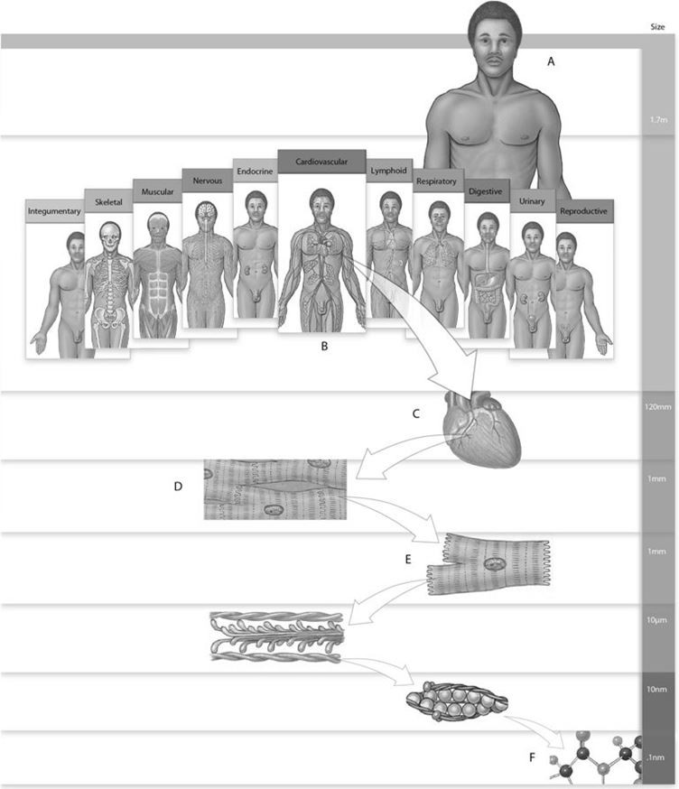

Using the figure above, answer the following questions.

1) Label A is which level of organization?
A) Molecular
B) Organ system
C) Tissue
D) Organism
E) Organ
Answer: D
Learning Outcome: 1.4
Bloom's Taxonomy: 1-2: Remembering/Understanding

2) Label D is which level of organization?
A) Organ system
B) Chemical
C) Tissue
D) Organ
E) Molecular
Answer: C
Learning Outcome: 1.4
Bloom's Taxonomy: 1-2: Remembering/Understanding

3) Label E is which level of organization?
A) Chemical
B) Organism
C) Cellular
D) Tissue
E) Organ system
Answer: C
Learning Outcome: 1.4
Bloom's Taxonomy: 1-2: Remembering/Understanding

4) Label F is which level of organization?
A) Organ
B) Tissue
C) Cellular
D) Organism
E) Chemical
Answer: E
Learning Outcome: 1.4
Bloom's Taxonomy: 1-2: Remembering/Understanding
Figure 1.2

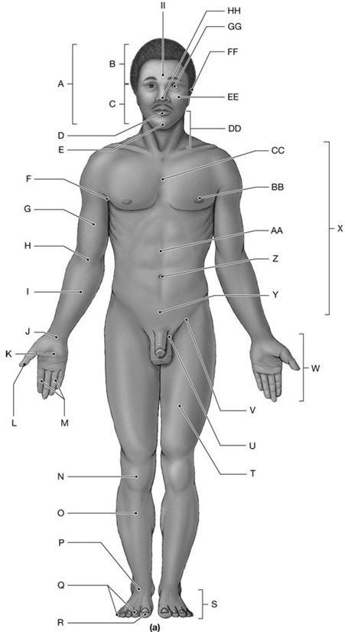

Using the figure above, answer the following questions.

5) What is the anatomical term for Label C?
A) Cranium
B) Bucca
C) Frons
D) Facies
E) Mentis
Answer: D
Learning Outcome: 1.6
Bloom's Taxonomy: 1-2: Remembering/Understanding
6) What is the anatomical term for Label I?
A) Antebrachium
B) Axilla
C) Brachium
D) Manus
E) Antecubitis
Answer: A
Learning Outcome: 1.6
Bloom's Taxonomy: 1-2: Remembering/Understanding

7) What is the anatomical term for Label L?
A) Pes
B) Carpus
C) Nasus
D) Hallux
E) Pollex
Answer: E
Learning Outcome: 1.6
Bloom's Taxonomy: 1-2: Remembering/Understanding

8) What is the anatomical term for Label N?
A) Palma
B) Popliteus
C) Patella
D) Pes
E) Planta
Answer: C
Learning Outcome: 1.6
Bloom's Taxonomy: 1-2: Remembering/Understanding

9) What is the anatomical term for Label O?
A) Sura
B) Carpus
C) Crus
D) Tarsus
E) Calcaneus
Answer: C
Learning Outcome: 1.6
Bloom's Taxonomy: 1-2: Remembering/Understanding

10) What is the anatomical term for Label R?
A) Auris
B) Popliteus
C) Pollex
D) Tarsus
E) Hallux
Answer: E
Learning Outcome: 1.6
Bloom's Taxonomy: 1-2: Remembering/Understanding
11) What is the anatomical term for Label S?
A) Pes
B) Planta
C) Palma
D) Patella
E) Pubis
Answer: A
Learning Outcome: 1.6
Bloom's Taxonomy: 1-2: Remembering/Understanding

12) What is the anatomical term for Label V?
A) Pubis
B) Inguen
C) Femur
D) Lumbus
E) Gluteus
Answer: B
Learning Outcome: 1.6
Bloom's Taxonomy: 1-2: Remembering/Understanding

13) What is the anatomical term for Label Z?
A) Abdomen
B) Dorsum
C) Inguen
D) Umbilicus
E) Lumbus
Answer: D
Learning Outcome: 1.6
Bloom's Taxonomy: 1-2: Remembering/Understanding

14) What is the anatomical term for Label FF?
A) Oris
B) Oculus
C) Auris
D) Nasus
E) Bucca
Answer: C
Learning Outcome: 1.6
Bloom's Taxonomy: 1-2: Remembering/Understanding
Figure 1.3

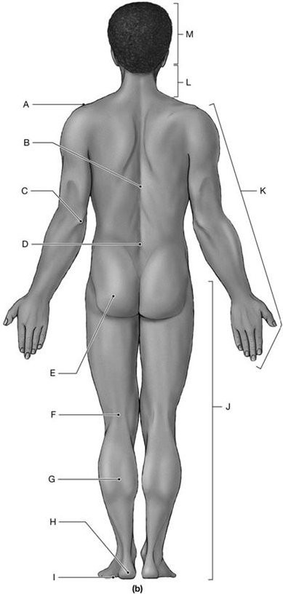

Using the figure above, answer the following questions.

15) What is the anatomical term for Label A?
A) Dorsum
B) Acromial
C) Cervicis
D) Cephalon
E) Olecranon
Answer: B
Learning Outcome: 1.6
Bloom's Taxonomy: 1-2: Remembering/Understanding
16) What is the anatomical term for Label C?
A) Antebrachium
B) Carpus
C) Antecubitis
D) Palma
E) Olecranon
Answer: E
Learning Outcome: 1.6
Bloom's Taxonomy: 1-2: Remembering/Understanding

17) What is the anatomical term for Label F?
A) Popliteus
B) Sura
C) Crus
D) Patella
E) Calcaneus
Answer: A
Learning Outcome: 1.6
Bloom's Taxonomy: 1-2: Remembering/Understanding

18) What is the anatomical term for Label H?
A) Tarsus
B) Pes
C) Calcaneus
D) Crus
E) Sura
Answer: C
Learning Outcome: 1.6
Bloom's Taxonomy: 1-2: Remembering/Understanding

19) What is the anatomical term for Label I?
A) Crus
B) Tarsus
C) Planta
D) Pes
E) Hallux
Answer: C
Learning Outcome: 1.6
Bloom's Taxonomy: 1-2: Remembering/Understanding

20) What is the anatomical term for Label L?
A) Cephalon
B) Cranium
C) Facies
D) Mentis
E) Cervicis
Answer: E
Learning Outcome: 1.6
Bloom's Taxonomy: 1-2: Remembering/Understanding
Figure 1.4

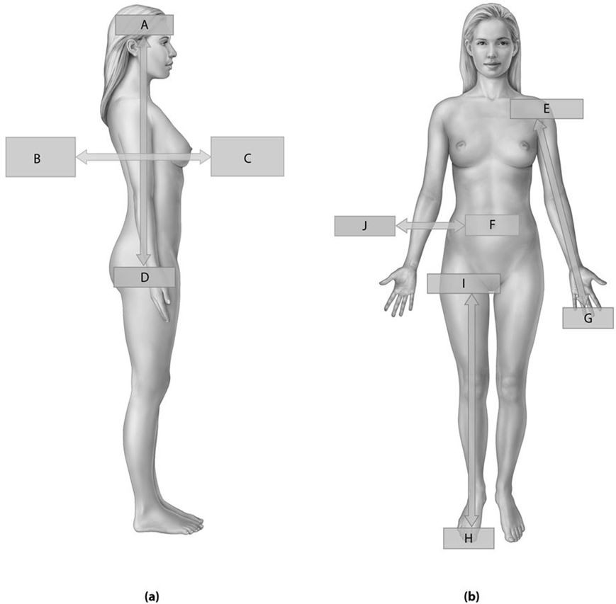

Using the figure above, answer the following questions.

21) What is the directional term for Label A?
A) Proximal
B) Cephalic
C) Ventral
D) Caudal
E) Superficial
Answer: B
Learning Outcome: 1.6
Bloom's Taxonomy: 1-2: Remembering/Understanding
22) What is the directional term for Label B?
A) Dorsal
B) Lateral
C) Distal
D) Anterior
E) Medial
Answer: A
Learning Outcome: 1.6
Bloom's Taxonomy: 1-2: Remembering/Understanding

23) What is the directional term for Label C?
A) Posterior
B) Proximal
C) Ventral
D) Deep
E) Caudal
Answer: C
Learning Outcome: 1.6
Bloom's Taxonomy: 1-2: Remembering/Understanding

24) What is the directional term for Label D?
A) Caudal
B) Dorsal
C) Superficial
D) Anterior
E) Superior
Answer: A
Learning Outcome: 1.6
Bloom's Taxonomy: 1-2: Remembering/Understanding

25) What is the directional term for Label E?
A) Inferior
B) Distal
C) Superficial
D) Proximal
E) Anterior
Answer: D
Learning Outcome: 1.6
Bloom's Taxonomy: 1-2: Remembering/Understanding

26) What is the directional term for Label F?
A) Ventral
B) Medial
C) Proximal
D) Lateral
E) Dorsal
Answer: B
Learning Outcome: 1.6
Bloom's Taxonomy: 1-2: Remembering/Understanding
27) What is the directional term for Label H?
A) Proximal
B) Inferior
C) Caudal
D) Dorsal
E) Distal
Answer: E
Learning Outcome: 1.6
Bloom's Taxonomy: 1-2: Remembering/Understanding

28) What is the directional term for Label J?
A) Anterior
B) Medial
C) Dorsal
D) Ventral
E) Lateral
Answer: E
Learning Outcome: 1.6
Bloom's Taxonomy: 1-2: Remembering/Understanding
Figure 1.5

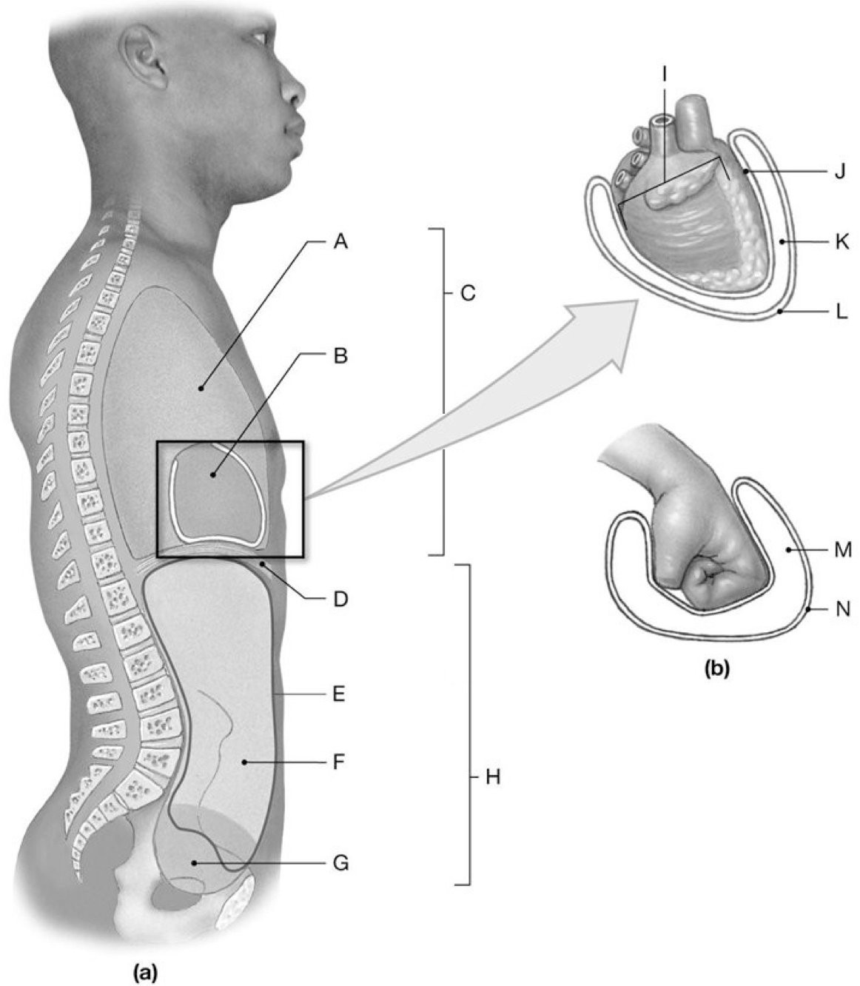

Using the figure above, answer the following questions.

29) What is the anatomical term for Label A?
A) Pericardial cavity
B) Peritoneal cavity
C) Pleural cavity
D) Pelvic cavity
E) Abdominal cavity
Answer: C
Learning Outcome: 1.6
Bloom's Taxonomy: 1-2: Remembering/Understanding
30) What is the anatomical term for Label B?
A) Pelvic cavity
B) Pericardial cavity
C) Peritoneal cavity
D) Pleural cavity
E) Visceral pleura
Answer: B
Learning Outcome: 1.6
Bloom's Taxonomy: 1-2: Remembering/Understanding

31) What is the anatomical term for Label C?
A) Pleural cavity
B) Peritoneal cavity
C) Thoracic cavity
D) Pericardial cavity
E) Abdominopelvic cavity
Answer: C
Learning Outcome: 1.6
Bloom's Taxonomy: 1-2: Remembering/Understanding

32) What is the anatomical term for Label D?
A) Peritoneum
B) Coelom
C) Abdominal cavity
D) Mediastinum
E) Diaphragm
Answer: E
Learning Outcome: 1.6
Bloom's Taxonomy: 1-2: Remembering/Understanding

33) What is the anatomical term for Label E?
A) Serous pericardium
B) Visceral pleura
C) Thoracic cavity
D) Peritoneal cavity
E) Parietal pericardium
Answer: D
Learning Outcome: 1.6
Bloom's Taxonomy: 1-2: Remembering/Understanding

34) What is the anatomical term for Label F?
A) Abdominal cavity
B) Pleural cavity
C) Thoracic cavity
D) Pelvic cavity
E) Mediastinum
Answer: A
Learning Outcome: 1.6
Bloom's Taxonomy: 1-2: Remembering/Understanding
35) What is the anatomical term for Label G?
A) Pleural cavity
B) Peritoneal cavity
C) Pericardial cavity
D) Abdominal cavity
E) Pelvic cavity
Answer: E
Learning Outcome: 1.6
Bloom's Taxonomy: 1-2: Remembering/Understanding

36) What is the anatomical term for Label H?
A) Thoracic cavity
B) Visceral pericardium
C) Diaphragm
D) Peritoneal cavity
E) Abdominopelvic cavity
Answer: E
Learning Outcome: 1.6
Bloom's Taxonomy: 1-2: Remembering/Understanding

37) What is the anatomical term for Label J?
A) Parietal pleura
B) Visceral pericardium
C) Visceral pleura
D) Parietal pericardium
E) Pericardial cavity
Answer: B
Learning Outcome: 1.6
Bloom's Taxonomy: 1-2: Remembering/Understanding

38) What is the anatomical term for Label K?
A) Pericardial cavity
B) Parietal pericardium
C) Peritoneal cavity
D) Thoracic cavity
E) Visceral pleura
Answer: A
Learning Outcome: 1.6
Bloom's Taxonomy: 1-2: Remembering/Understanding

39) What is the anatomical term for Label L?
A) Mediastinum
B) Visceral pleura
C) Parietal peritoneum
D) Parietal pericardium
E) Visceral peritoneum
Answer: D
Learning Outcome: 1.6
Bloom's Taxonomy: 1-2: Remembering/Understanding

